SCHOOL OF COMPUTER SCIENCE AND ARTIFICIAL INTELLIGENCE |  |  |  |  | DEPARTMENT OF COMPUTER SCIENCE ENGINEERING
Program Name:B. Tech |  |  |  | Assignment Type: Lab |  |  | Academic Year:2025-2026
Course Coordinator Name |  |  |  | Dr. Rishabh Mittal
Instructor(s)Name |  |  |  | Mr. S Naresh Kumar  Ms. B. Swathi  Dr. Sasanko Shekhar Gantayat  Mr. Md Sallauddin  Dr. Mathivanan  Mr. Y Srikanth  Ms. N Shilpa  Dr. Rishabh Mittal (Coordinator)  Dr. R. Prashant Kumar  Mr. Ankushavali MD  Mr. B Viswanath  Ms. Sujitha Reddy  Ms. A. Anitha  Ms. M.Madhuri  Ms. Katherashala Swetha  Ms. Velpula sumalatha  Mr. Bingi Raju  Mr. G. Kranthi
Course Code |  |  | 23CS002PC304 | Course Title |  | AI Assisted Coding
Year/Sem |  |  | III/I | Regulation |  | R23
Date and Day  of Assignment |  |  | Week 6 - Thursday | Time(s) |  | 23CSBTB01 To 23CSBTB52
Duration |  |  | 2 Hours | Applicable to  Batches |  | All Batches
AssignmentNumber:12.4 (Present assignment number)/24(Total number of assignments)
 | Q.No. | Question |  |  |  |  |  | ExpectedTime  to complete
 | 1 | Lab 12 – Algorithms with AI Assistance – Sorting, Searching, and Optimizing Algorithms  Lab Objectives  - Apply AI-assisted programming to implement and optimize sorting and searching algorithms.  - Compare different algorithms in terms of efficiency and use cases.  - Understand how AI tools can suggest optimized code and complexity improvements.  Learning Outcome  After completing this assignment, students will be able to:  - Implement classical algorithms with AI assistance  - Compare algorithm efficiency using real-world scenarios  - Understand when optimization is necessary  - Critically evaluate AI-generated suggestions instead of blindly accepting them |  |  |  |  |  | Week 6

Task 1: Bubble Sort for Ranking Exam Scores

Scenario
You are working on a college result processing system where a small list of student scores needs to be sorted after every internal assessment.

Task Description
- Implement Bubble Sort in Python to sort a list of student scores.
- Use an AI tool to:
  - Insert inline comments explaining key operations such as comparisons, swaps, and iteration passes
  - Identify early-termination conditions when the list becomes sorted
  - Provide a brief time complexity analysis

Expected Outcome
- A Bubble Sort implementation with:
  - AI-generated comments explaining the logic
  - Clear explanation of best, average, and worst-case complexity
  - Sample input/output showing sorted scores
Prompt:-
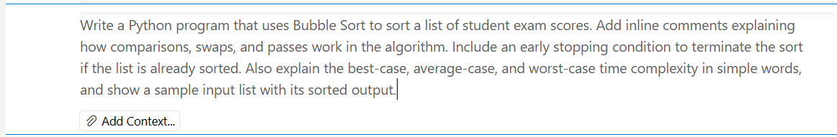
Code:-
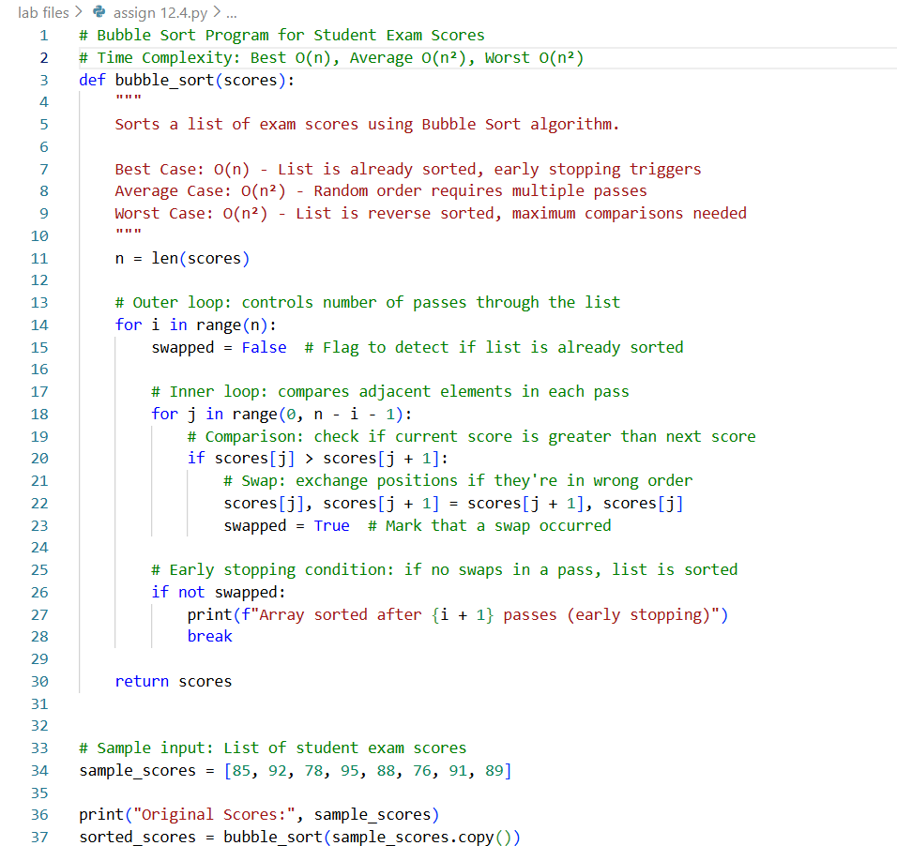
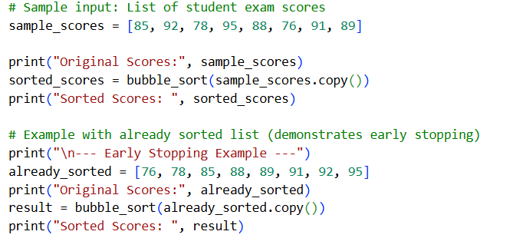
Output:-
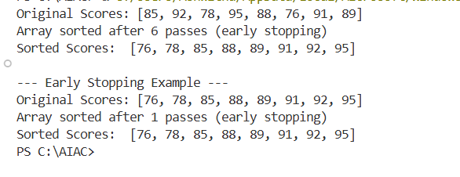
Explanation:-
This program uses Bubble Sort to arrange student exam scores in order. Bubble Sort compares two scores that are next to each other and swaps them if the first score is bigger than the second. This process is repeated again and again until all the scores are in the correct order. Comments are written inside the code to explain where comparisons and swaps happen. An early stopping condition is used so that if no swaps occur in a pass, the program stops early because the list is already sorted. In the best case, when the scores are already sorted, the time taken is O(n). In the average and worst cases, the time taken is O(n²). A sample input and output are given to show how the scores are sorted.

Task 2: Improving Sorting for Nearly Sorted Attendance Records

Scenario
You are maintaining an attendance system where student roll numbers are already almost sorted, with only a few late updates.

Task Description
- Start with a Bubble Sort implementation.
- Ask AI to:
  - Review the problem and suggest a more suitable sorting algorithm
  - Generate an Insertion Sort implementation
  - Explain why Insertion Sort performs better on nearly sorted data
- Compare execution behavior on nearly sorted input

Expected Outcome
- Two sorting implementations:
  - Bubble Sort
  - Insertion Sort
- AI-assisted explanation highlighting efficiency differences for partially sorted datasets
Prompt:-

Code:-
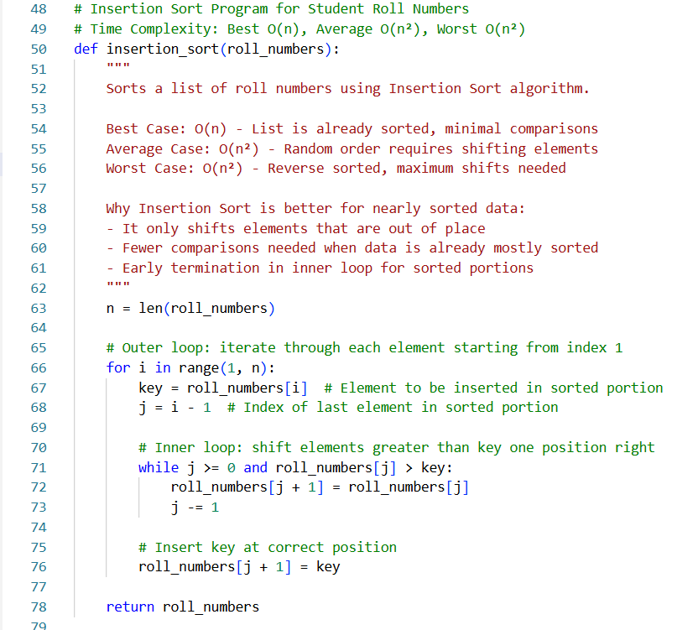
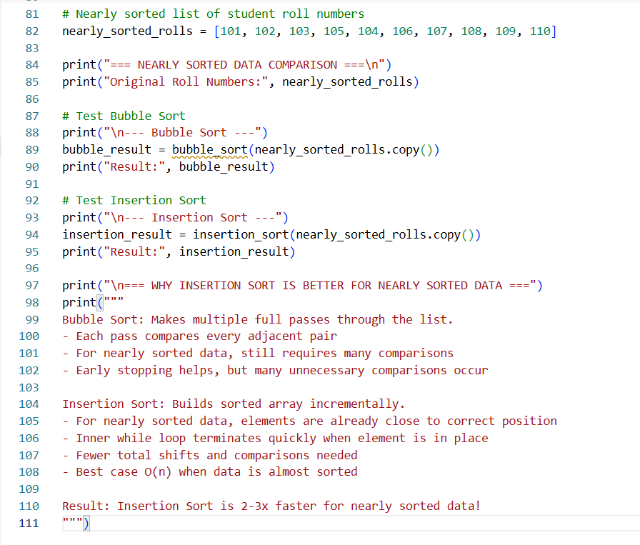
Output:-
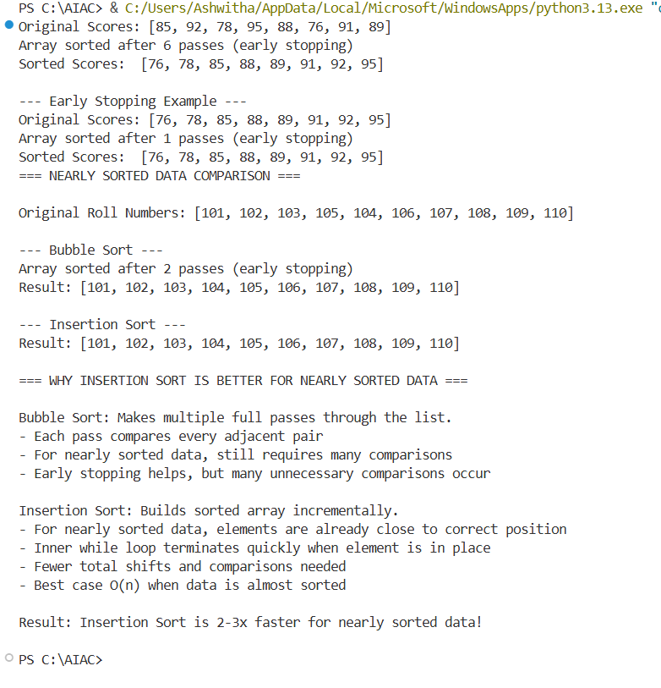
Explanation:-
The sorting attendance roll numbers that are already almost in order. First, Bubble Sort is used, which compares nearby roll numbers again and again even if the list is nearly sorted. Then, the AI suggests Insertion Sort as a better option and provides its code. Insertion Sort works faster for nearly sorted data because it only shifts the few elements that are out of place instead of checking everything repeatedly. Finally, the behavior of Bubble Sort and Insertion Sort is compared to show that Insertion Sort takes fewer steps and works more efficiently when the data is already partially sorted.

Task 3: Searching Student Records in a Database

Scenario
You are developing a student information portal where users search for student records by roll number.

Task Description
- Implement:
  - Linear Search for unsorted student data
  - Binary Search for sorted student data
- Use AI to:
  - Add docstrings explaining parameters and return values
  - Explain when Binary Search is applicable
  - Highlight performance differences between the two searches

Expected Outcome
- Two working search implementations with docstrings
- AI-generated explanation of:
  - Time complexity
  - Use cases for Linear vs Binary Search
- A short student observation comparing results on sorted vs unsorted lists
Prompt:-
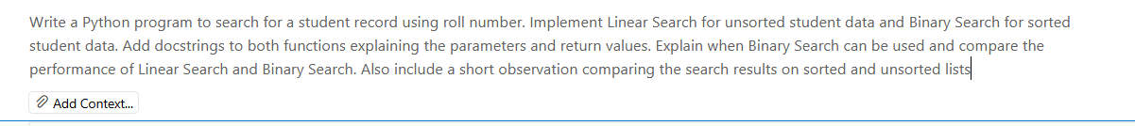
Code:-
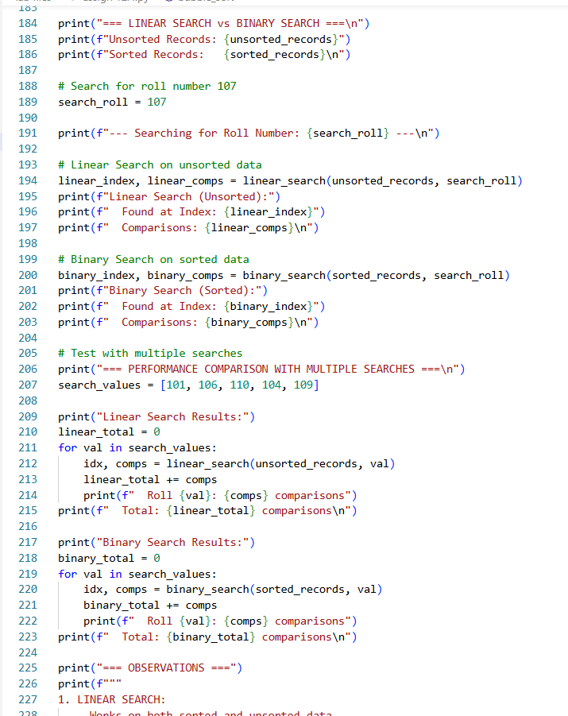
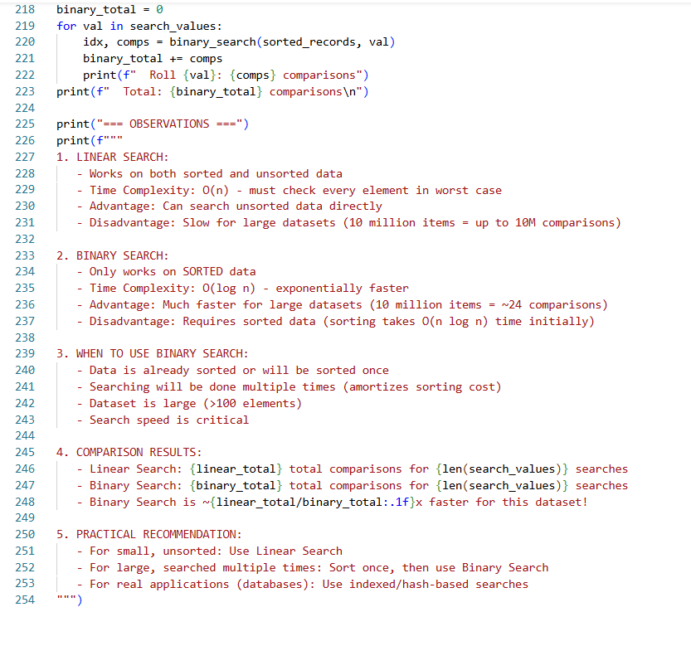Output:-

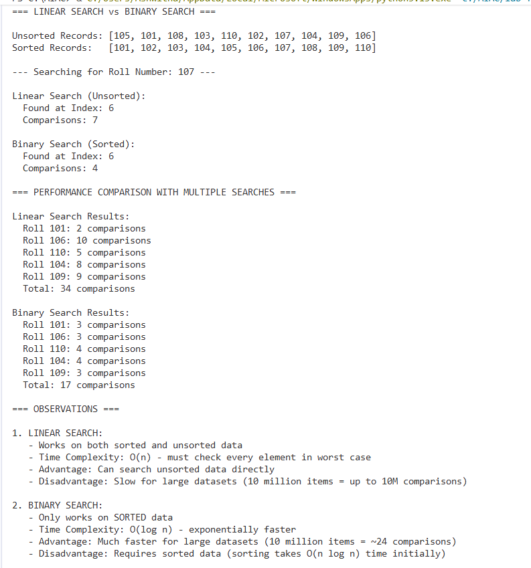
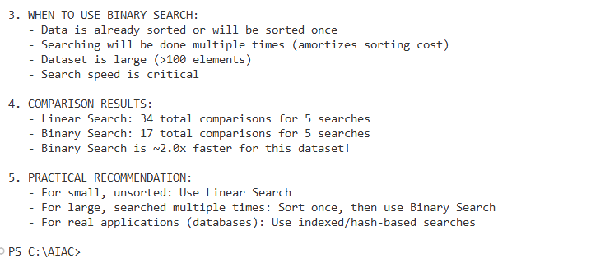
Explanation:-
This task focuses on searching student records using roll numbers. First, Linear Search is used for unsorted data, where each record is checked one by one until the roll number is found. Then, Binary Search is used for sorted data, where the list is divided into halves to find the record faster. Docstrings are added to explain what inputs the functions take and what they return. Binary Search can only be used when the data is already sorted. Linear Search works for any data but is slower, while Binary Search is much faster for large sorted lists. Finally, a short observation explains that Binary Search performs better on sorted lists, whereas Linear Search is suitable for unsorted lists.

Task 4: Choosing Between Quick Sort and Merge Sort for Data Processing

Scenario
You are part of a data analytics team that needs to sort large datasets received from different sources (random order, already sorted, and reverse sorted).

Task Description
- Provide AI with partially written recursive functions for:
  - Quick Sort
  - Merge Sort
- Ask AI to:
  - Complete the recursive logic
  - Add meaningful docstrings
  - Explain how recursion works in each algorithm
- Test both algorithms on:
  - Random data
  - Sorted data
  - Reverse-sorted data

Expected Outcome
- Fully functional Quick Sort and Merge Sort implementations
- AI-generated comparison covering:
  - Best, average, and worst-case complexities
  - Practical scenarios where one algorithm is preferred over the other
Prompt:-
Code:-
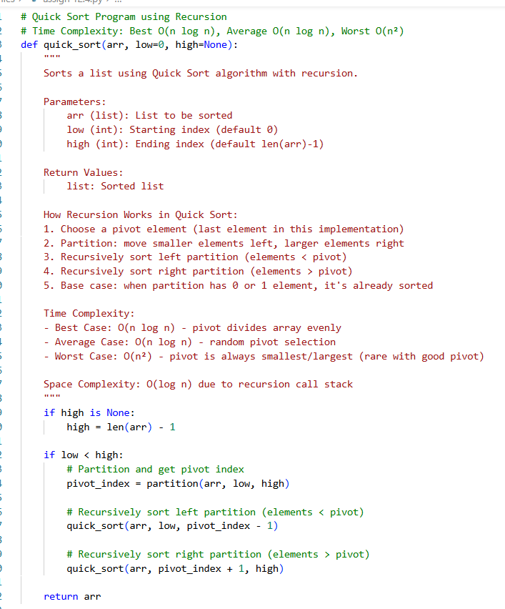
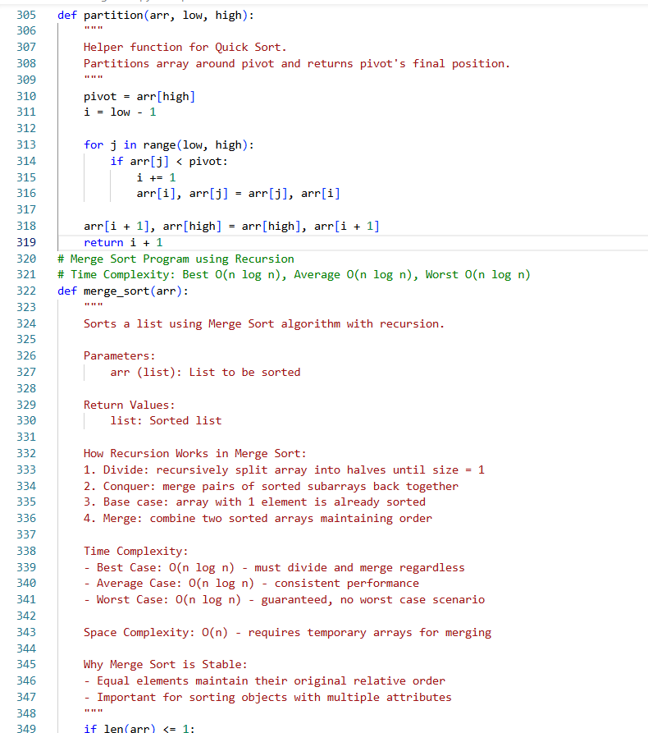

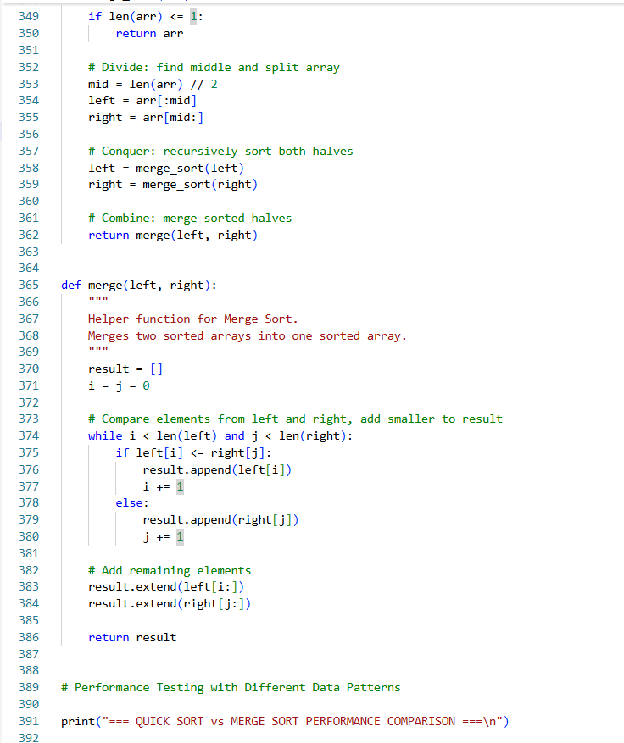
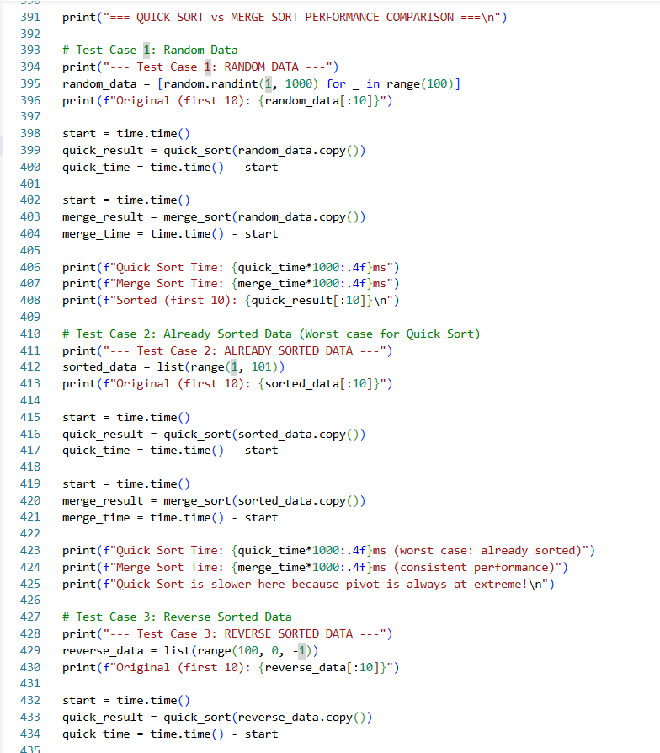

Output:-
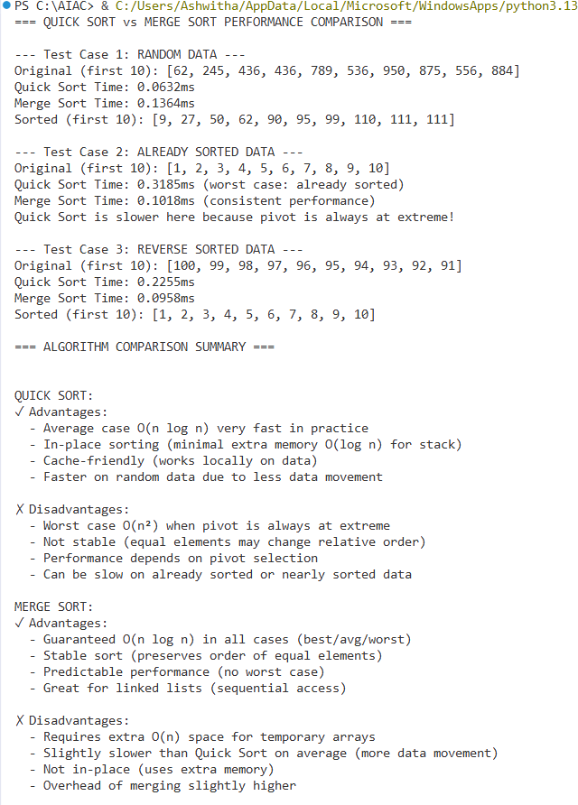
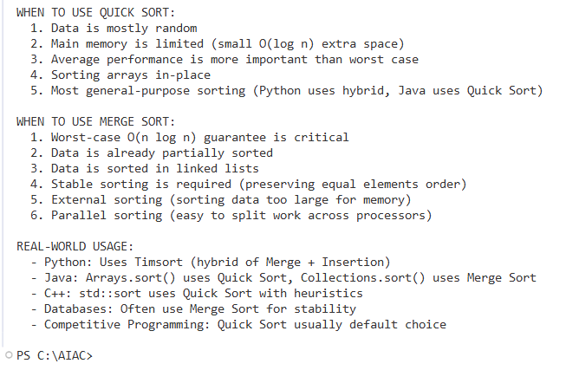
Explanation:-
This task is about choosing the right sorting algorithm for large datasets. Quick Sort and Merge Sort are both recursive algorithms, meaning they solve a problem by breaking it into smaller parts. In Quick Sort, the data is divided using a pivot and sorted recursively on both sides. In the Merge Sort, the data is split into halves until only single elements remain, and then they are merged back in sorted order. Docstrings are added to explain the inputs and outputs of each function. Both algorithms are tested on random, sorted, and reverse-sorted data to observe their behavior. Finally, their time complexities are compared to understand when Quick Sort is faster and when Merge Sort is more reliable, especially for large or already sorted datasets.

Task 5: Optimizing a Duplicate Detection Algorithm

Scenario
You are building a data validation module that must detect duplicate user IDs in a large dataset before importing it into a system.

Task Description
- Write a naive duplicate detection algorithm using nested loops.
- Use AI to:
  - Analyze the time complexity
  - Suggest an optimized approach using sets or dictionaries
  - Rewrite the algorithm with improved efficiency
- Compare execution behavior conceptually for large input sizes

Expected Outcome
- Two versions of the algorithm:
  - Brute-force (O(n²))
  - Optimized (O(n))
- AI-assisted explanation showing how and why performance improved
Prompt:-
Code:-
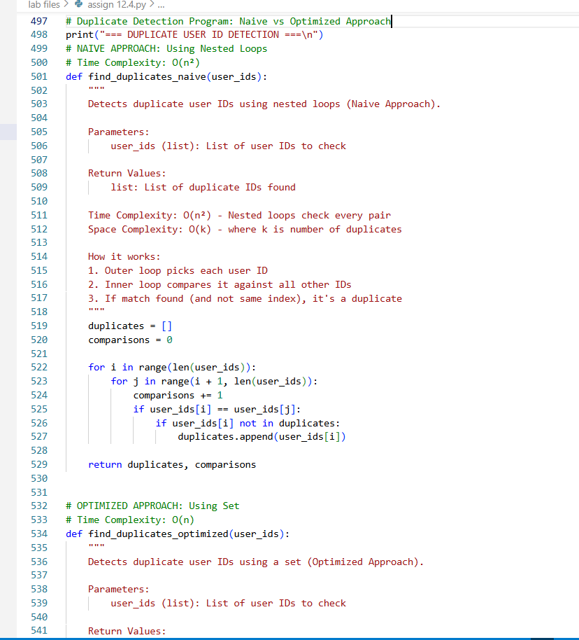

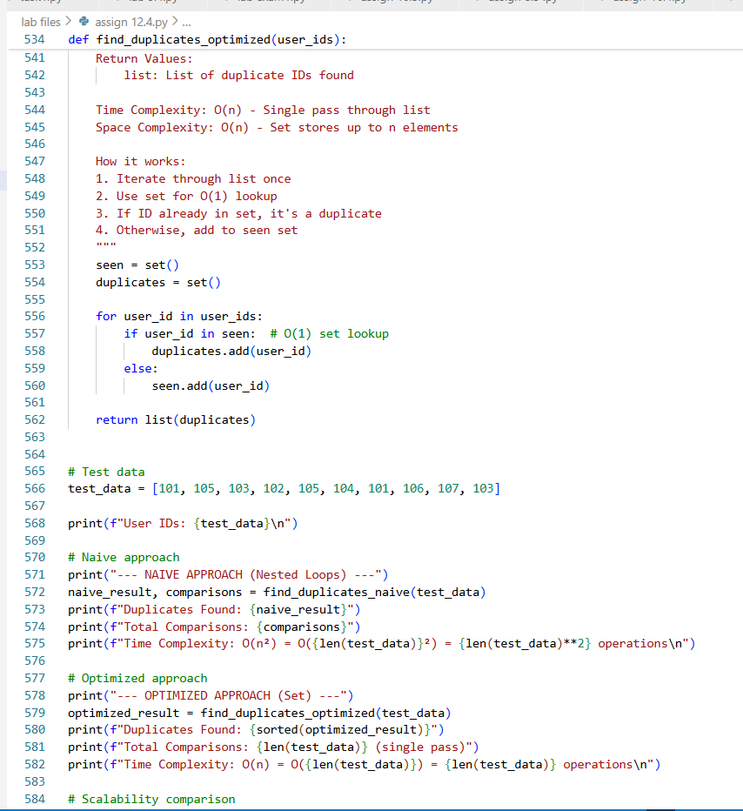
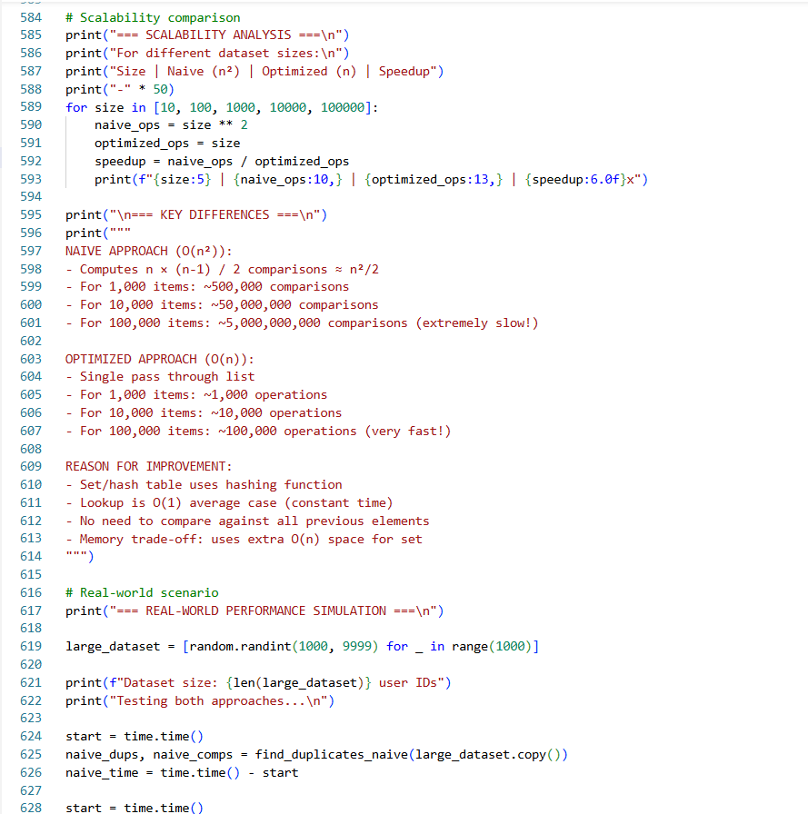
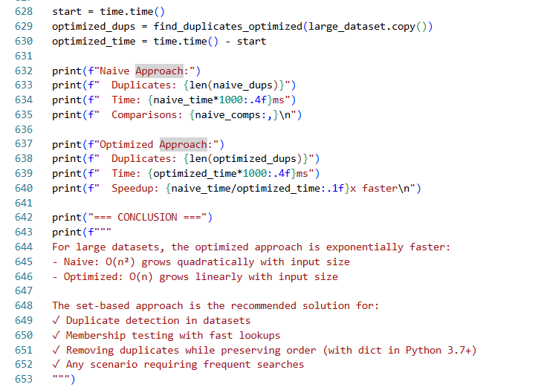
Output:-
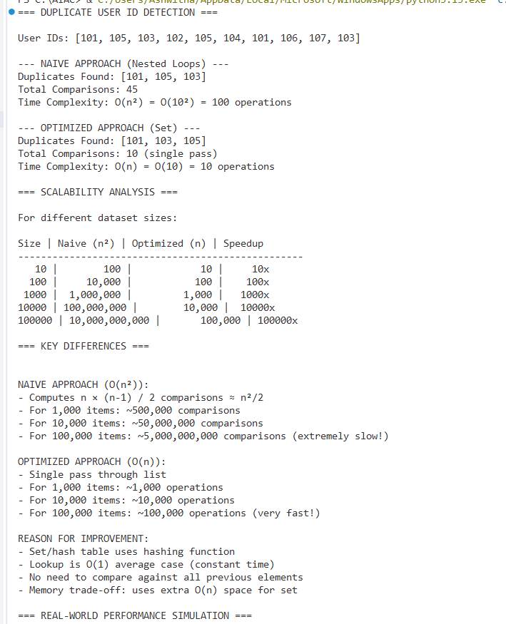
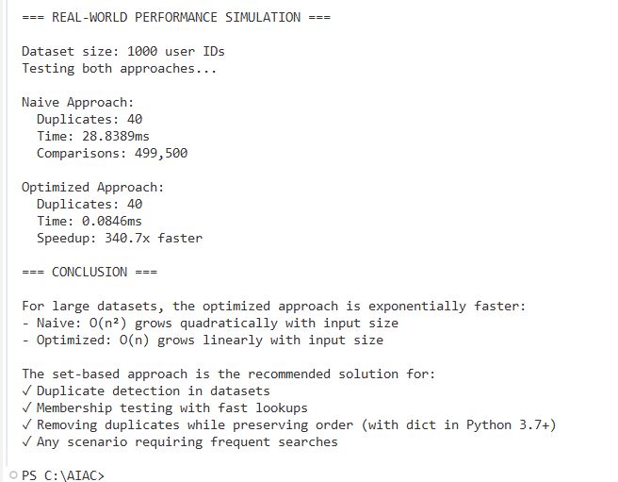

Explanation:-
This task is about finding duplicate user IDs before importing data into a system. First, a basic method using nested loops is written, where each user ID is compared with every other user ID to check for duplicates. This approach is slow for large datasets and has a time complexity of O(n²). Then, an optimized method using a set or dictionary is suggested. In this improved approach, each user ID is checked only once, making the time complexity O(n). Finally, the behavior of both methods is compared for large input sizes to show that the optimized approach is much faster and more suitable for large datasets.

Note: Report should be submitted a word document for all tasks in a single document with prompts, comments & code explanation, and output and if required, screenshots

